API INTEGRATION AND DATA MIGRATION

The aim for Day 3 was to seamlessly integrate API data into Sanity CMS for the Bandage project. This integration allowed dynamic content updates for the marketplace, replacing the need for manual data entry with a more efficient and scalable solution.

1. 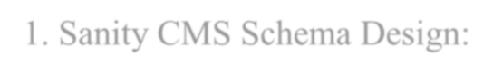Sanity CMS Schema Design:

To efficiently manage product data, I created a schema named **product** in Sanity CMS. The schema includes the following fields:

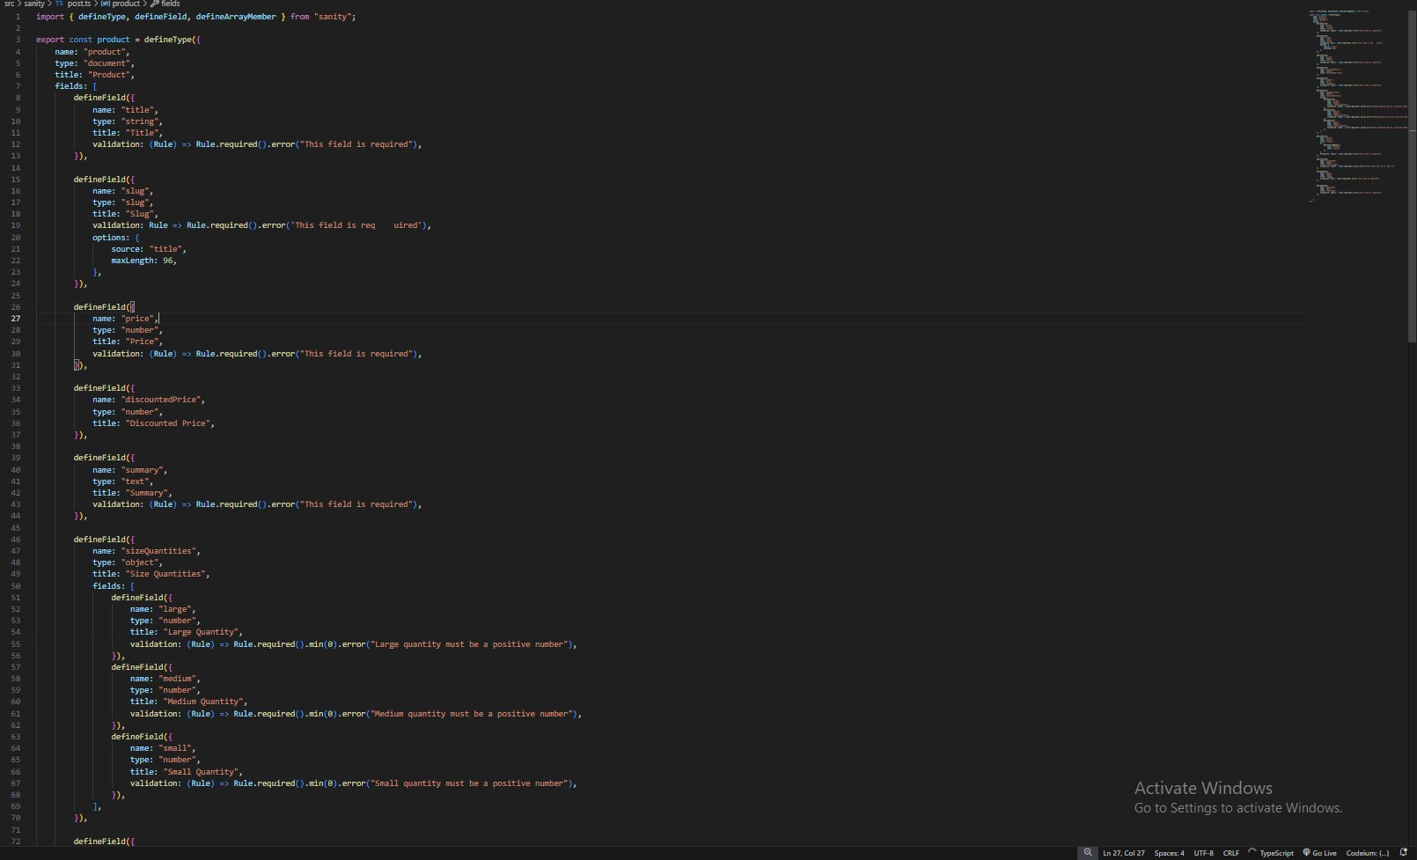

1. 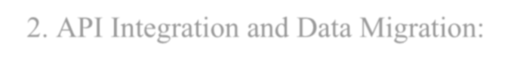API Integration and Data Migration:
   * **API Data Fetching:**

I retrieved product data from an external API, which included key details such as images, titles, descriptions, prices, and tags. This data was then mapped to the relevant fields in the **Sanity CMS** schema.

* + **Data Population in Sanity CMS:**

After fetching the API data, I dynamically populated the product fields in Sanity CMS. This approach enabled the automated input of product information, ensuring consistency and accuracy across the platform while reducing manual effort.

* + **Data Migration:**

Utilizing the **Sanity CLI**, I exported the dataset from Sanity CMS for backup purposes and later re-imported it during testing. This ensured that the data remained well-structured and displayed correctly throughout the migration process.

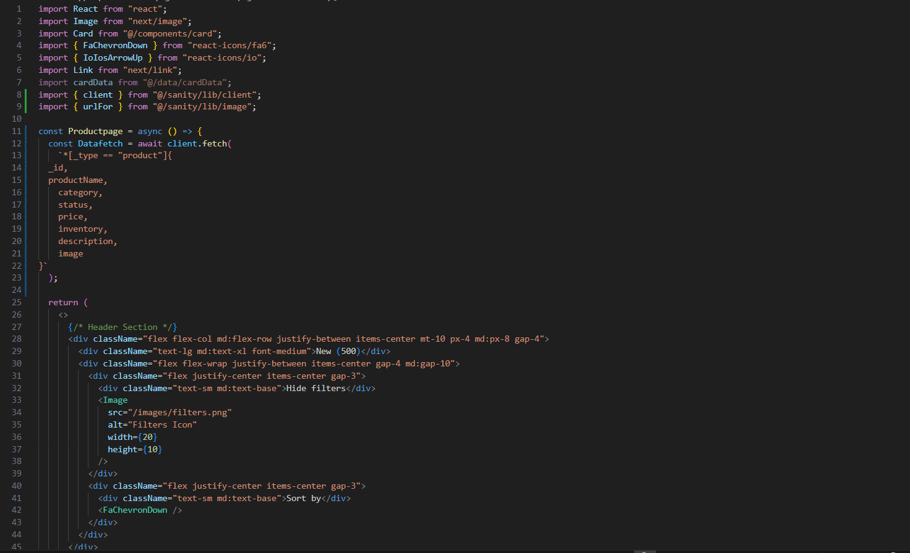

1. 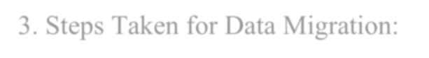Steps Taken for Data Migration:
   * **Exporting Data:**

The first step involved exporting the data from **Sanity CMS** using the Sanity CLI. This ensured that all product data was securely backed up before performing any further operations.

* + **Verification of Data:**

The exported JSON structure was carefully reviewed to confirm that all fields were correctly populated. This step was critical to ensure the data would display accurately when fetched and rendered on the frontend.

* + **Re-importing Data:**

Once verified, the dataset was re-imported into **Sanity CMS**. This process validated that the data migration was successful and confirmed the system was functioning as expected.

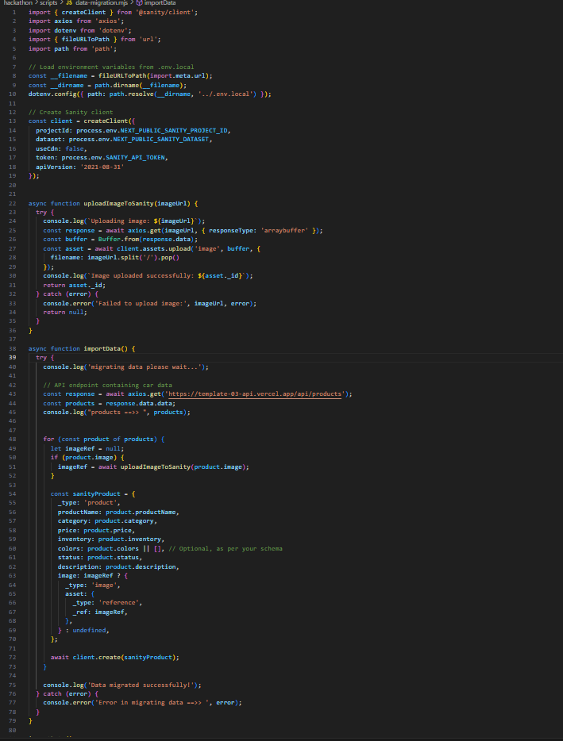

**4**

**.**

**Tools Used:**

**Sanity Studio**

:

Used for schema creation, content management, and displaying product data



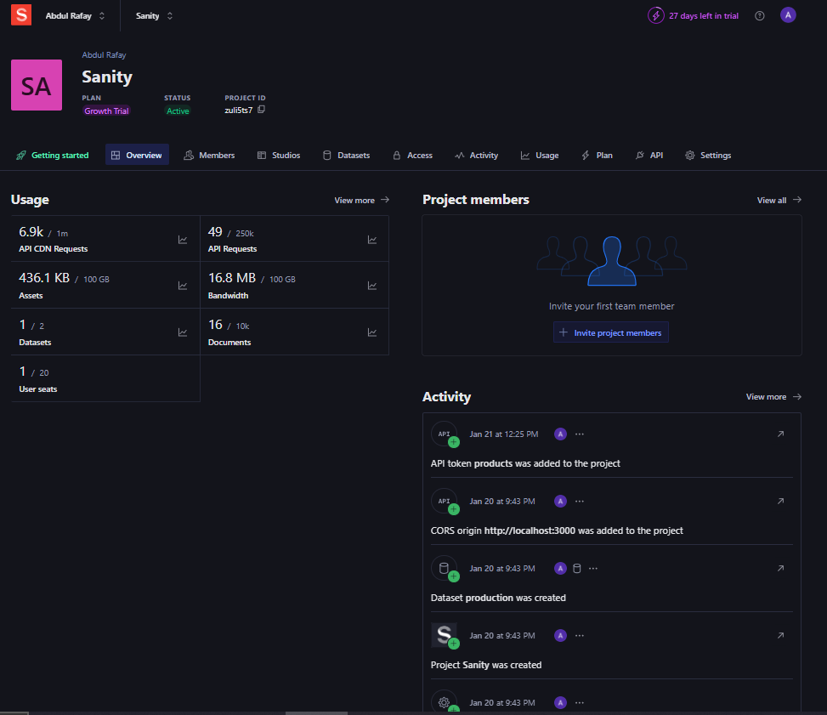

**Sanity Vision:**

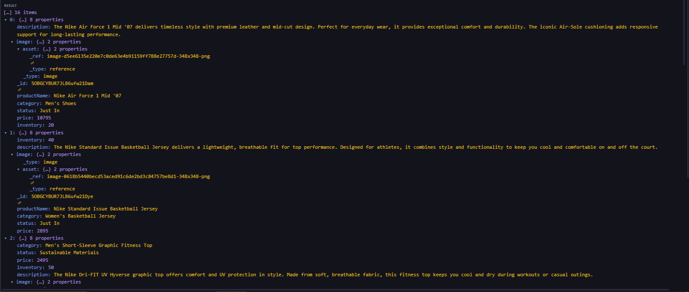

5. Screenshots Display:

• **Sanity CMS Fields:**

A screenshot showcasing the populated fields in **Sanity Studio**, displaying product details such as images, descriptions, and prices.



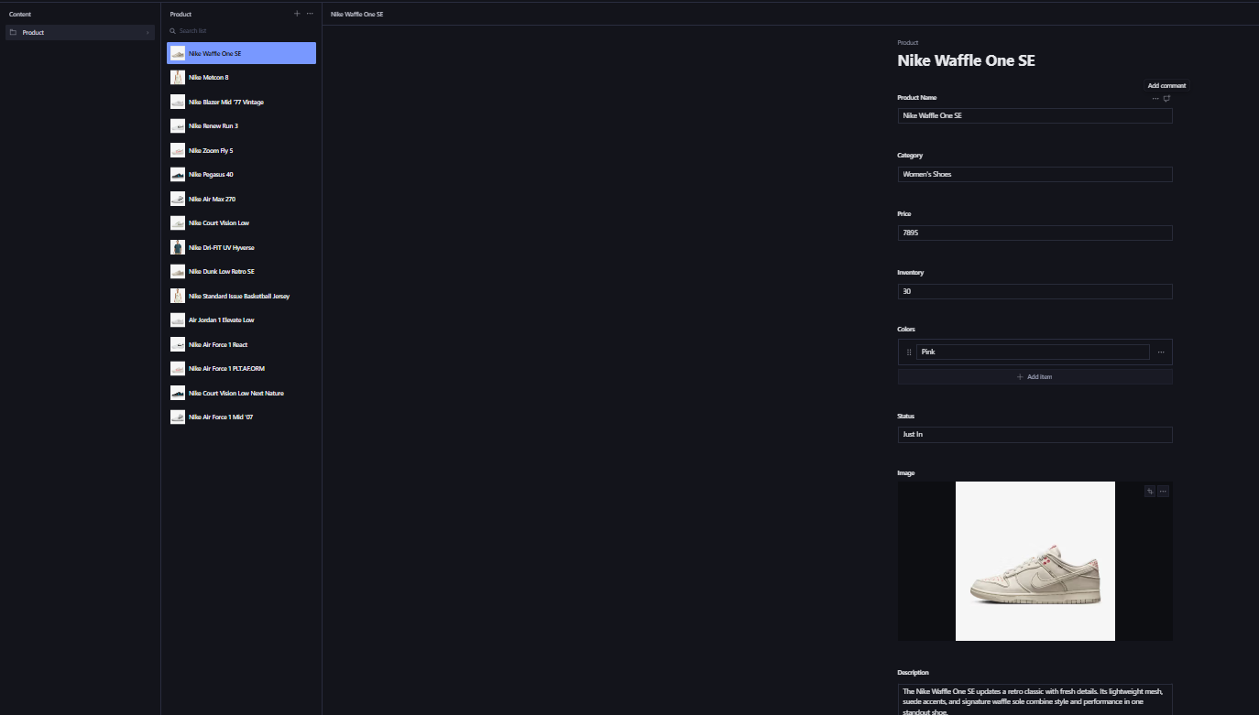



**Conclusion:**

The **API integration** and **data migration** processes were successfully implemented, significantly improving the efficiency and scalability of the Bandage project. The integration eliminated manual data entry, streamlining the addition and updating of product information. Meanwhile, the migration steps ensured that the data remained consistent and accurate across the system.

This setup makes the Bandage project more dynamic, robust, and easier to maintain, laying the foundation for continued growth and scalability.

